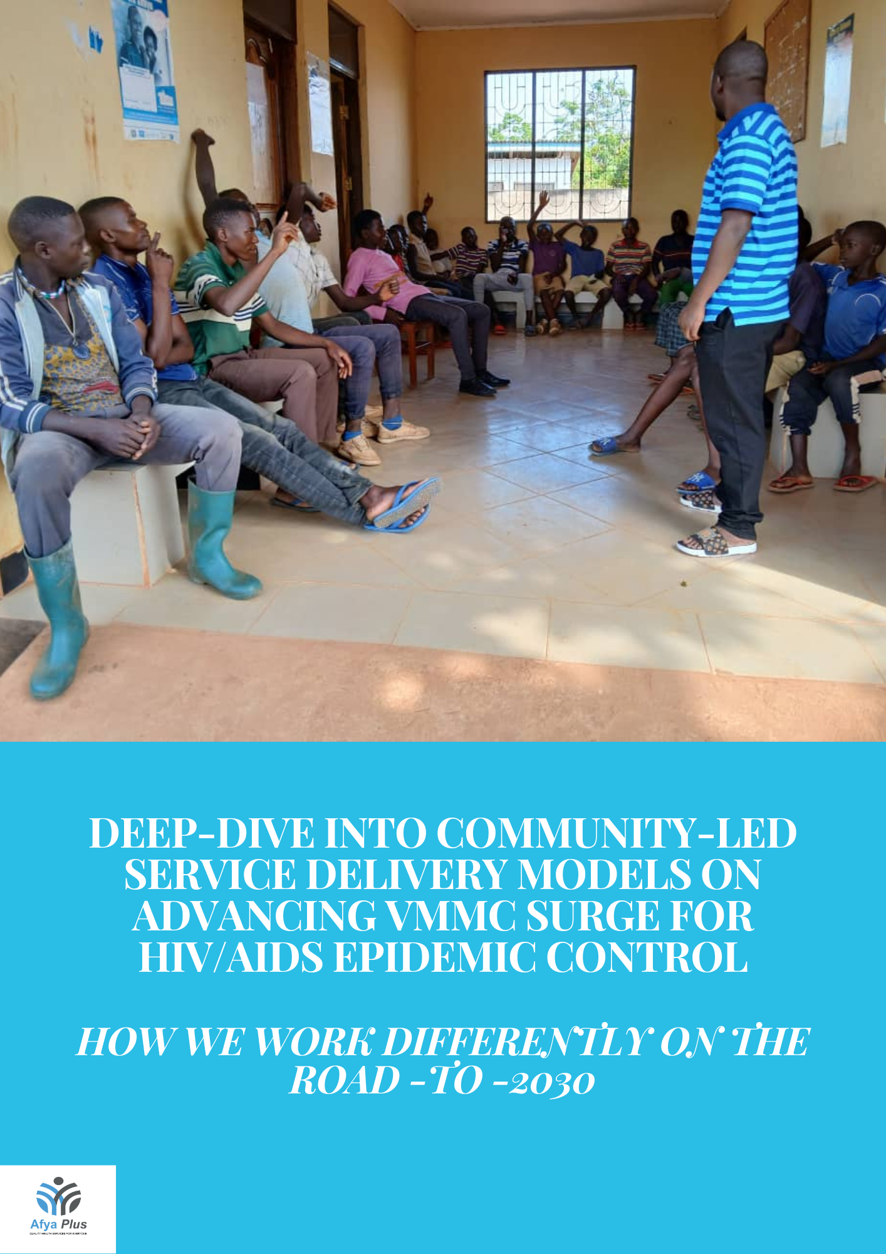

\
Introduction
The Voluntary Medical Male Circumcision (VMMC) program stands as a critical pillar in the comprehensive approach to combatting HIV/AIDS. VMMC is a unique, ‘once-off’ prevention method that protect males against HIV infection. The impact of VMMC on driving the reduction of new HIV infections increase considerably when combined with other behavior change interventions. VMMC aims to reduce HIV transmission risk among men in the countries including Tanzania where such programs have been prioritized. In this endeavor, the Afya Plus in collaboration with Tanzania Health Promotion Support (THPS) under the CDC/PEPFAR Afya Hatua project, plays a pivotal role in supporting scaling up and sustainability of this cost-effective prevention model while integrating it with other essential health services of men’s preferences with the purpose of creating a better platform for influencing their positive health seeking behaviors to ultimately contributes to the consistent reductions of new HIV infections specifically among adolescents and young people in the country. Operating at sub-role capacity, Afya Plus works tirelessly to expand sustainable VMMC services in Shinyanga region. This article delves into the innovative strategies and community-led service delivery models employed by Afya Plus to advance VMMC goals for maximum impact.

Coverage Expansion
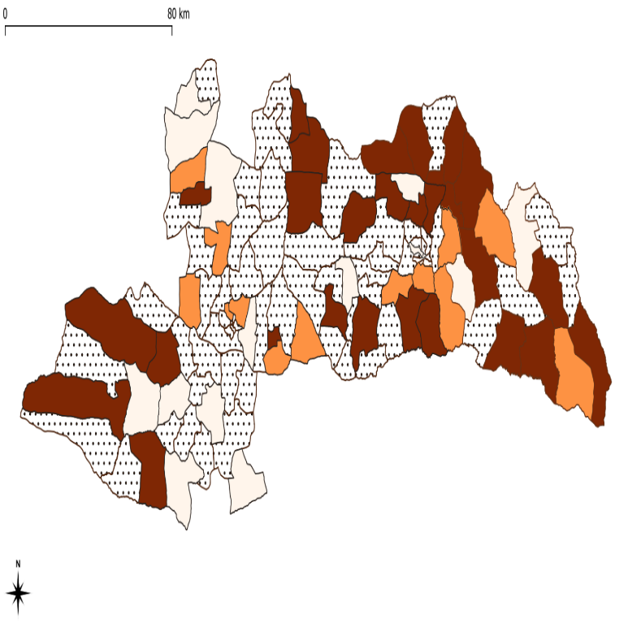
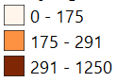

Afya Plus, in collaboration with the Shinyanga regional health management team and respective council health management teams, supported VMMC service delivery through both static sites and informed facility-led outreach activities. The integration of VMMC services into 35 existing health facilities ensured adherence to rigorous quality standards and continuity of service delivery for a long-term impact. Additionally, 60 targeted outreach sites extended services to underserved communities. Community engagement facilitated by Community Volunteering Agents (CVAs) and Community Health Workers (CHWs), bolstering demand alignment efforts. Human-centered design principles underpinned SBC efforts in breaking experienced barriers. Radio sessions and public announcements amplified further awareness, dispelled misconceptions around VMMC, fostered community trust, and acceptance which are instrumental in decision-action journey. Printed materials and social media campaigns enriched health-seeking behaviors. Modalities like pick-and-drop services and pre-booking streamline improved access to underserved men segments, while catering to diverse client’s needs and preferences.
FY24 Q1-Q2 VMMC covered wards

Service Delivery Models
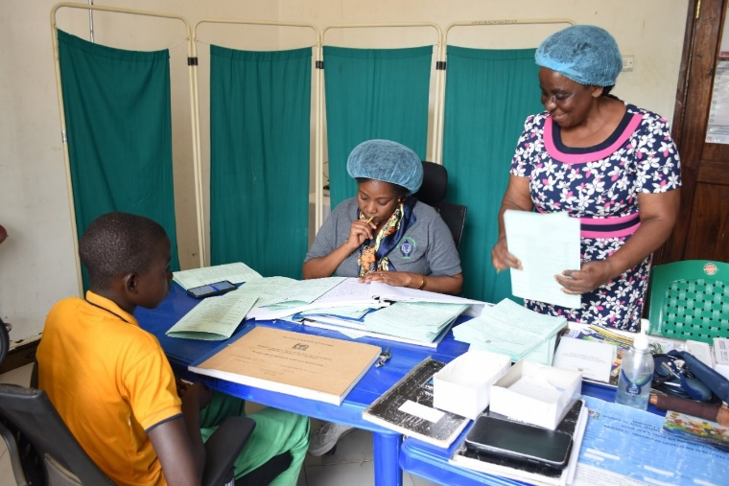
Afya Plus employed a multifaceted approach to service delivery, emphasizing quality and innovation. Static sites provided consistent care, while facility-led outreach extended services to distant underserved communities. The utilization of the ShangRingTM device underscored a commitment to safe and user-friendly circumcision methods. Data management systems ensured real-time monitoring and evaluation, facilitated prompt decision-making and continuous quality improvement efforts.

Performance Analysis
Despite challenges like distractions from agriculture activities and other seasonal factors, significant progress was evident. Four of the six targeted SNUs exceeded quarterly targets, showcasing the efficacy of the data-driven community-led interventions. To enhance performance, strategies leveraging dry seasons were planned and scaled up. Overall, the regional performance stands at 51.5% towards the annual VMMC surge target of 91,022 by the end of Quarter two, underscoring the need for continued learning, innovation, adaptation and scale up of promising evidence-based practices to sustain the gains made.

HIV Testing and Referral
The program's holistic approach extended beyond circumcision, encompassing HIV testing and linkage to care. Utilizing risk screening tools, over 6,000 clients were tested, with one new HIV-positive client identified and linked to treatment services. Furthermore, the distribution of HIV self-testing kits enhanced accessibility and encouraged partner testing.

Follow-up and Monitoring
Achieving a 100% follow-up rate within 14 days post-circumcision reflects a commitment to comprehensive care for better outcomes. Robust monitoring systems, coupled with community tracing mechanisms, ensured timely intervention and adverse event management. Continuous quality improvement initiatives drive preventative measures and reinforce infection control protocols.

Internal Quality Assurance
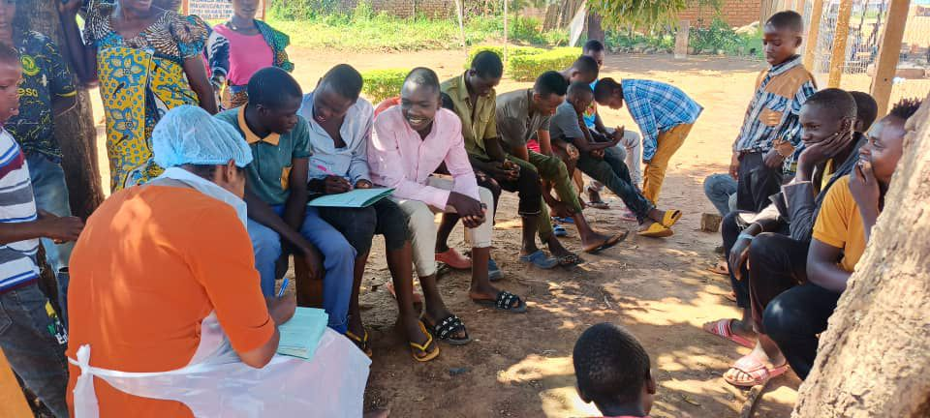
Internal quality assessments affirmed adherence to national standards, identified strengths were capitalized and areas for improvement addressed to optimize quality service delivery and enhance data management systems. Challenges like facility saturation and staff shortages were addressed through informed outreach, targeted training initiatives and complimented efforts from Community Volunteering Agents (CVAs) and Community Health Workers who helped to bridge the follow-up gap within the health care system.

Monitoring and Evaluation
Data cleaning and routine reporting ensured data accuracy and completeness, enabling informed decision-making. Through real-time analysis and GIS mapping, performance trends were identified and addressed. The Unified Community System (UCS)-VMMC module enhanced data capture efficiency, though challenges necessitate ongoing refinement and system integration.

Conclusion
Underpinning community-led service delivery models with the use of granular, disaggregated data to focus interventions more precisely for maximum impact; with a growing emphasis on adapting services to fit people’s needs are pivotal in advancing VMMC surge goals. Afya Plus’s innovative approach, rooted in community engagement and quality assurance, demonstrates tangible progress in HIV/AIDS epidemic control. Through strategic partnerships, a move to functionally integrated community-led interventions as well as continuous learning and adaptation; the path towards achieving VMMC surge targets and ending of HIV/AIDS in 2030 remains promising, laying a foundation for sustainable impact in the public health arena.

Acknowledgement
We gratefully acknowledge the dedication of Tanzania Health Promotion Support (THPS) led CDC/PEPFAR supported Afya Hatua project team of which Afya Plus is part of it, in advancing the Voluntary Medical Male Circumcision (VMMC) program in Tanzania. Their collaborative efforts, innovative strategies, and community engagement have been crucial in reducing new HIV infections and enhancing men's health outcomes, particularly in Shinyanga region. Special thanks to CDC/PEPFAR team, regional and council health management teams for their guidance and support; Community Volunteering Agents (CVAs), Community Health Workers (CHWs), and all stakeholders for their hard work and commitment.

Disclaimer
This document is based on the work of the Tanzania Health Promotion Support (THPS) led CDC/PEPFAR supported Afya Hatua project in Shinyanga region where Afya Plus plays a sub role. While efforts have been made to ensure accuracy, the authors do not guarantee the information's validity or reliability. The content is for informational purposes only and does not constitute medical or professional advice. Actions taken based on this information are at the reader's own risk, and the authors disclaim any liability for any loss or damage arising from its use.

